n8n Automation — Learner Guide
  - A Step-by-Step Workbook for Eight Hands-On Activities
This guide walks you through building eight automation workflows in n8n from scratch — from an enquiry flyer form, a data-capture table, a conditional email response and a Telegram-triggered AI chat agent, through to a Retrieval-Augmented Generation (RAG) knowledge bot, a webhook-powered chatbot, a multi-endpoint HTTP integration, and an AI safety guardrail. Each activity includes the node-by-node setup, the exact field values, the credentials/API keys you need, and a screenshot of the finished workflow. The matching workflow JSON files are also provided so you can import a working copy and compare it with your own build.

Contents
Before You Begin 1
What is n8n? 1
Key terms 1
Accounts and API keys you will need 1
Setting up the Gmail credential (OAuth2) 1
Setting up the Telegram Bot token 1
Setting up the OpenAI API key 1
Importing the provided JSON workflows 1
Activity 1: Flyer with QR Code 1
Goal 1
Workflow overview 1
Step-by-step build 1
Step 1 — Create the workflow and add the form trigger 1
Step 2 — Add and configure the Gmail node 1
Step 3 — Connect, save, and activate 1
Step 4 — Get the form’s Production URL 1
Step 5 — Make the QR code and flyer 1
Activity 2: Capture Data in a Table 1
Goal 1
Workflow overview 1
Step-by-step build 1
Step 1 — Create the Data Table 1
Step 2 — Add the form trigger 1
Step 3 — Add the If (branch) node 1
Step 4 — Gmail node on the true branch 1
Step 5 — Insert row nodes (both branches) 1
Step 6 — Connect, save, test 1
Activity 3: Conditional Response 1
Goal 1
Workflow overview 1
Step-by-step build 1
Step 1 — Form trigger 1
Step 2 — If node 1
Step 3 — Gmail on the true branch 1
Step 4 — No Operation on the false branch 1
Step 5 — Save and test 1
Why use No Operation? 1
Activity 4: Telegram-Triggered AI Agent 1
Goal 1
Workflow overview 1
Credentials needed for this activity 1
Step-by-step build 1
Step 1 — Create the Telegram bot and credential 1
Step 2 — Add the Telegram Trigger 1
Step 3 — Add the AI Agent 1
Step 4 — Attach the OpenAI Chat Model 1
Step 5 — Attach Simple Memory 1
Step 6 — Send the reply back to Telegram 1
Step 7 — Activate and test 1
How the AI Agent fits together 1
Activity 5: Retrieval-Augmented Generation (RAG) 1
Goal 1
What is RAG? 1
Workflow overview 1
Credentials needed 1
Build — Part A: Ingestion (build the knowledge base) 1
Step 1 — Upload form 1
Step 2 — Extract from File 1
Step 3 — Simple RAG Vector Store (insert) 1
Step 4 — Document loader + splitter (under the vector store) 1
Build — Part B: Query (chat with the knowledge base) 1
Step 5 — Chat trigger 1
Step 6 — AI Agent 1
Step 7 — Attach the model, memory, and the RAG tool 1
Step 8 — Run it (the three-step routine) 1
Activity 6: Webhook Chatbot 1
Goal 1
Workflow overview 1
Credentials needed 1
Step-by-step build 1
Step 1 — Webhook trigger 1
Step 2 — AI Agent 1
Step 3 — Attach the OpenAI Chat Model 1
Step 4 — Respond to Webhook 1
Step 5 — Activate and test 1
Webhook vs. chat trigger 1
Activity 7: HTTP Request 1
Goal 1
Workflow overview 1
Get a Twelve Data API key 1
Step-by-step build 1
Step 1 — Manual trigger 1
Step 2 — Config (Set node) 1
Step 3 — Time Series HTTP request 1
Step 4 — Technical Indicators HTTP request 1
Step 5 — Run and inspect 1
Why a Config node? 1
Activity 8: AI Guardrail 1
Goal 1
Workflow overview 1
Credentials needed 1
Step-by-step build 1
Step 1 — Manual trigger 1
Step 2 — Edit Fields (sample data) 1
Step 3 — Split Out 1
Step 4 — Secret Keys (Guardrails node) 1
Step 5 — Email approval on the Fail branch 1
Step 6 — Run and observe 1
Why guardrails matter 1
You’re Done! 1
Where to go next 1

Before You Begin

What is n8n?
n8n (pronounced “n-eight-n”) is a workflow-automation tool. You build automations visually by dragging nodes onto a canvas and connecting them. Each node performs one task — trigger on a form submission, send an email, branch on a condition, call an AI model — and data flows from left to right along the connecting lines.

Key terms
Node: a single step in the workflow (a box on the canvas).
Trigger node: the node that starts the workflow (it has a lightning-bolt icon). Examples used here: On form submission and Telegram Trigger.
Connection: the line linking one node’s output to the next node’s input.
Credential: a saved, reusable login (Gmail, Telegram, OpenAI) that nodes use to authenticate. You create a credential once and pick it from a dropdown in any node.
Expression: a dynamic value wrapped in double curly braces that pulls data from an earlier node, e.g. {{ $json.Name }}.

Accounts and API keys you will need
Set these up before starting so you are not interrupted mid-activity. You only need each one once — it is then reused across activities.
Service / API | Used in | What to create | Where to get it
n8n account | All activities | A free n8n Cloud account, or a self-hosted instance | n8n.io → Start free trial (Cloud), or run via Docker/npm locally
Gmail (OAuth2) | Activities 1, 2, 3 | A Gmail OAuth2 credential to send email | Google Cloud Console (OAuth client) + Gmail account
Telegram Bot token | Activity 4 | A bot token from BotFather | Telegram app → chat with @BotFather
OpenAI API key | Activity 4 | An API key for the GPT model | platform.openai.com → API keys
n8n Data Table | Activity 2 | A Data Table named “Bowling Party” | Created inside n8n (no external key)

Setting up the Gmail credential (OAuth2)
Activities 1–3 send an email with the Gmail node. Create the credential once:
- In n8n, open any Gmail node and click the Credential to connect with dropdown → Create New Credential.
- Choose Gmail OAuth2. n8n shows an OAuth Redirect URL — copy it.
- In Google Cloud Console, create a project, enable the Gmail API, and configure the OAuth consent screen (External; add your own email as a test user).
- Create an OAuth client ID of type Web application, paste the n8n redirect URL into Authorized redirect URIs, and copy the Client ID and Client Secret.
- Paste the Client ID and Client Secret back into n8n, click Sign in with Google, and approve access.
- Save the credential as “Gmail account”. It is now selectable in every Gmail node.
Tip: While the Google app is in “Testing” mode, only the email addresses you add as test users can authenticate. Add your own Gmail there.

Setting up the Telegram Bot token
Activity 4 needs a Telegram bot. Create one with BotFather:
- In Telegram, search for @BotFather and start a chat.
- Send /newbot, then follow the prompts to name your bot and give it a username ending in “bot”.
- BotFather replies with an HTTP API token that looks like 123456789:AAH… — copy it and keep it private.
- In n8n, create a Telegram credential, paste the token as the Access Token, and save it as “Telegram account”.
- To find your personal chat ID (needed to receive replies), message your bot once, or chat with @userinfobot which returns your numeric ID.

Setting up the OpenAI API key
- Sign in at platform.openai.com and ensure your account has billing/credit enabled.
- Go to API keys → Create new secret key and copy the key (starts with sk-…). You can only view it once.
- In n8n, create an OpenAI credential, paste the key, and save it as “OpenAI account”.
Note: OpenAI API usage is billed per token and is separate from a ChatGPT Plus subscription — you need API credit for the model to respond.

Importing the provided JSON workflows
Each activity comes with a ready-made workflow file. To load one as a reference:
- In n8n, open the Workflows list and click the … (three-dots) menu → Import from File.
- Select the activity’s .json file (e.g. Activity1_ Flyer with QR Code.json).
- The full workflow appears on the canvas. Re-select your own credentials in each Gmail / Telegram / OpenAI node — credentials are not transferred with the file.
- Compare the imported version against the steps below as you build your own.

Activity 1: Flyer with QR Code

Goal
Build an online enquiry form. When someone submits it, n8n automatically emails the enquiry details to you. You then turn the form’s public URL into a QR code and place it on a printed or digital flyer, so people can scan it to open your form.

Workflow overview
Two nodes connected in a line: On form submission → Send a message (Gmail).
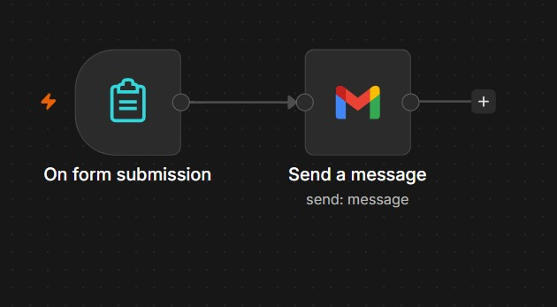
Figure 1: The finished Activity 1 workflow.

Step-by-step build

Step 1 — Create the workflow and add the form trigger
- Click Create Workflow (or the + New) and give it a name, e.g. Activity1: Flyer with QR Code.
- Click the + on the canvas, search for Form, and add On form submission (n8n Form Trigger).
- Set Form Title to Enquiry Form and Form Description to Enquiry about my service.
Add these four form fields (click Add Form Element for each):
Field Label | Field Type | Options / Notes
What's your name? | Text | Default text field
What's your email | Email | Validates an email address
What is your gender | Radio Buttons | Add two options: Male, Female
What is your favorite food? | Textarea | Multi-line answer

Step 2 — Add and configure the Gmail node
- From the form trigger’s + output, search Gmail and add the Send a message action (Message → Send).
- Under Credential to connect with, choose your saved Gmail account credential (set up in Before You Begin).
- Set To to the address that should receive enquiries, e.g. agenticautomation88@gmail.com.
- Set Subject to New Enquiry.
- Switch the Message field to Expression / HTML and paste the body below.
Email message (HTML with expressions):
Hi <br> <br>
There is a new enquiry. <br> <br>
Name: {{ $json["What's your name?"] }} <br>
Email: {{ $json["What's your email"] }} <br>
Gender: {{ $json["What is your gender"] }} <br>
Food: {{ $json["What is your favorite food?"] }} <br>
Each {{ }} expression pulls the matching answer from the form submission. The field name inside the brackets must exactly match the Field Label, including the question mark.

Step 3 — Connect, save, and activate
- Make sure the connection runs On form submission → Send a message.
- Click Save, then toggle the workflow Active (top-right). A form trigger only serves its public Production URL when the workflow is active.

Step 4 — Get the form’s Production URL
- Open the On form submission node and copy the Production URL (not the Test URL).
- Paste it into a browser to confirm the live form loads and that submitting it sends you the email.

Step 5 — Make the QR code and flyer
- Go to any free QR-code generator and paste the form’s Production URL to generate a QR image.
- Open PowerPoint or Canva and design a flyer for your service.
- Place the QR code on the flyer with a short call to action, e.g. “Scan to enquire”.
- Test the flyer by scanning the QR code with your phone — it should open the live form.
Checkpoint: Submitting the form sends a formatted enquiry email to your inbox, and scanning the flyer’s QR code opens the same form.

Activity 2: Capture Data in a Table

Goal
Build an RSVP form for a bowling party. When someone submits it, the workflow checks whether they are attending. If they are, it emails the operations team and saves their details to a Data Table marked as attending. If they are not, it still saves their details, but marked as not attending. This gives you a single table with every response.

Workflow overview
On form submission → If. The If node has two outputs: the true branch goes to Send a message (Gmail) → Insert row; the false branch goes to Insert row1. Both Insert nodes write to the same Data Table.
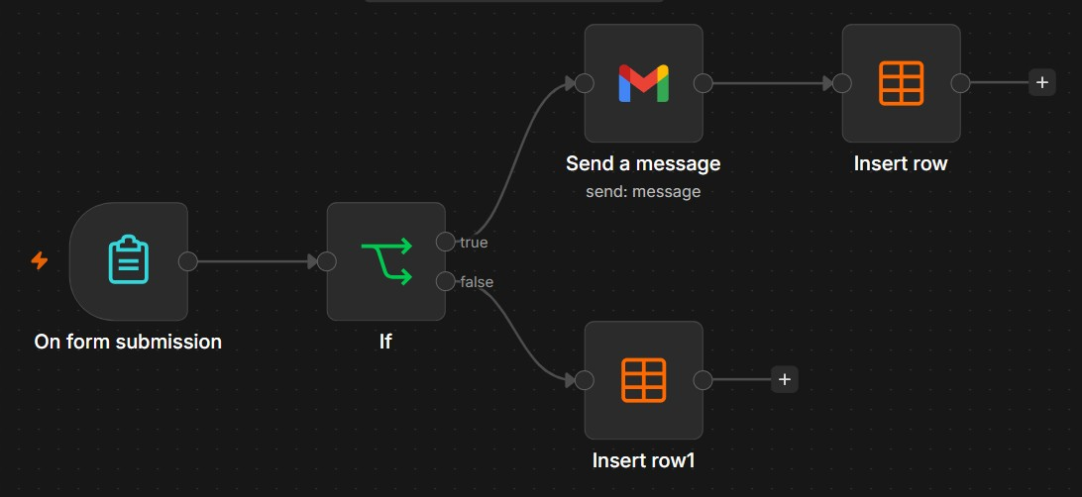
Figure 2: The finished Activity 2 workflow.

Step-by-step build

Step 1 — Create the Data Table
A Data Table is n8n’s built-in spreadsheet-like store. Create it first so the Insert nodes can reference it.
- In your n8n project, open Data Tables and click Create Data Table. Name it Bowling Party.
- Add the following columns with the exact names and types shown below.
Column name | Type | Purpose
Name | String | Attendee’s name
Email | String | Attendee’s email
Tel | Number | Phone number
Attending | Boolean | true = yes, false = no
Message | String | Free-text message

Step 2 — Add the form trigger
- Add an On form submission node. Set Form Title and Form Description to Bowling Party Attendance.
- In the form options, turn off Append n8n Attribution (optional, removes the n8n footer).
- Add these five form fields:
Field Label | Field Type | Options / Notes
Name | Text | Default text field
Email | Email | Validates an email
Tel | Number | Numeric phone field
Are you attending the bowling party | Radio Buttons | Options: Yes, No
Message | Textarea | Free-text message

Step 3 — Add the If (branch) node
- From the form trigger, add an If node.
- Set the condition’s left value to the expression: {{ $json["Are you attending the bowling party"] }}
- Set the operator to String → is equal to.
- Set the right value to Yes.
- Enable Ignore case so “yes” and “Yes” both match.
The If node sends matching submissions (attending = Yes) out of its true output, and everything else out of its false output.

Step 4 — Gmail node on the true branch
- From the If node’s true output, add a Gmail → Send a message node.
- Choose your Gmail account credential.
- Set To to the operations inbox, e.g. angch@tertiaryinfotech.com.
- Set Subject to Operation Request.
- Set the Message (HTML) to the body below.
Hi Operation Team <br> <br>
There is a new operation request. The details are below: <br>
Name: {{ $json.Name }} <br>
Email: {{ $json.Email }} <br>
Tel: {{ $json.Tel }} <br>
Message: {{ $json.Message }} <br> <br>
Thanks <br> Operation

Step 5 — Insert row nodes (both branches)
Add a Data Table → Insert row node on each branch so every response is recorded. Both point to the Bowling Party table.
On the true branch (after the Gmail node) — node “Insert row”:
- Set Data Table to Bowling Party.
- Set Mapping to Map each column manually and fill in the values below.
Column | Value
Name | {{ $('On form submission').item.json.Name }}
Email | {{ $('On form submission').item.json.Email }}
Tel | {{ $('On form submission').item.json.Tel }}
Attending | true
Message | {{ $('On form submission').item.json.Message }}

On the false branch — node “Insert row1”:
Identical to Insert row, except set Attending to false. (Tip: copy the Insert row node and paste it onto the false branch, then change only the Attending value.)

Step 6 — Connect, save, test
- Confirm the wiring: form → If; If true → Send a message → Insert row; If false → Insert row1.
- Save and activate the workflow, then submit the form once with Yes and once with No.
- Open the Bowling Party Data Table — you should see both rows, with Attending true and false respectively, and an email only for the Yes submission.
Checkpoint: Every submission lands in the Data Table; attendees also generate an email to the operations team.

Activity 3: Conditional Response

Goal
Use the same bowling-party RSVP form, but with simpler logic: only act when someone is attending. If the answer is Yes, email the operations team. If the answer is No, the workflow ends quietly without doing anything. This activity teaches the If node together with the No Operation node — a clean way to stop a branch on purpose.

Workflow overview
On form submission → If. The true branch goes to Send a message (Gmail); the false branch goes to No Operation, do nothing.
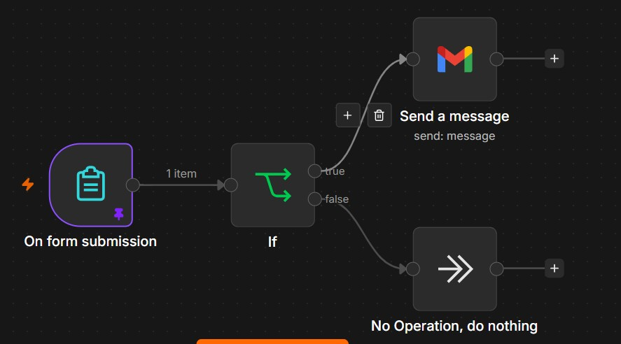
Figure 3: The finished Activity 3 workflow.

Step-by-step build
This activity reuses the form, If, and Gmail nodes from Activity 2. If you built Activity 2, you can duplicate it and remove the two Insert row nodes.

Step 1 — Form trigger
Add an On form submission node with the same five fields as Activity 2: Name (Text), Email (Email), Tel (Number), Are you attending the bowling party (Radio: Yes / No), and Message (Textarea).

Step 2 — If node
- Add an If node after the form.
- Left value (expression): {{ $json["Are you attending the bowling party"] }}
- Operator: String → is equal to. Right value: Yes. Enable Ignore case.

Step 3 — Gmail on the true branch
- From the If true output, add Gmail → Send a message and select your Gmail credential.
- To: angch@tertiaryinfotech.com. Subject: Operation Request.
- Use the same HTML message body as Activity 2 (Name / Email / Tel / Message expressions).

Step 4 — No Operation on the false branch
- From the If false output, add a No Operation, do nothing node.
- It needs no configuration — it simply ends that branch cleanly so non-attendees trigger no action.

Step 5 — Save and test
- Confirm: form → If; If true → Send a message; If false → No Operation, do nothing.
- Save and activate. Submit once with Yes (you receive an email) and once with No (nothing happens).
Checkpoint: Only attendees generate an email; non-attendees end at the No Operation node with no side effects.

Why use No Operation?
The No Operation node is a deliberate “do nothing” endpoint. It keeps the false branch tidy and makes the workflow’s intent obvious to anyone reading it, instead of leaving the branch unconnected.

Activity 4: Telegram-Triggered AI Agent

Goal
Build a Telegram chatbot powered by an AI agent. When you message your Telegram bot, the message is sent to an AI Agent that uses an OpenAI model (GPT-4o) and short-term memory to generate a reply, and the bot sends that reply back to you in Telegram. The memory lets the agent remember earlier messages in the same conversation.

Workflow overview
Telegram Trigger → AI Agent → Send a text message. Two helper nodes plug into the AI Agent from below: OpenAI Chat Model (its language model) and Simple Memory (its conversation memory).
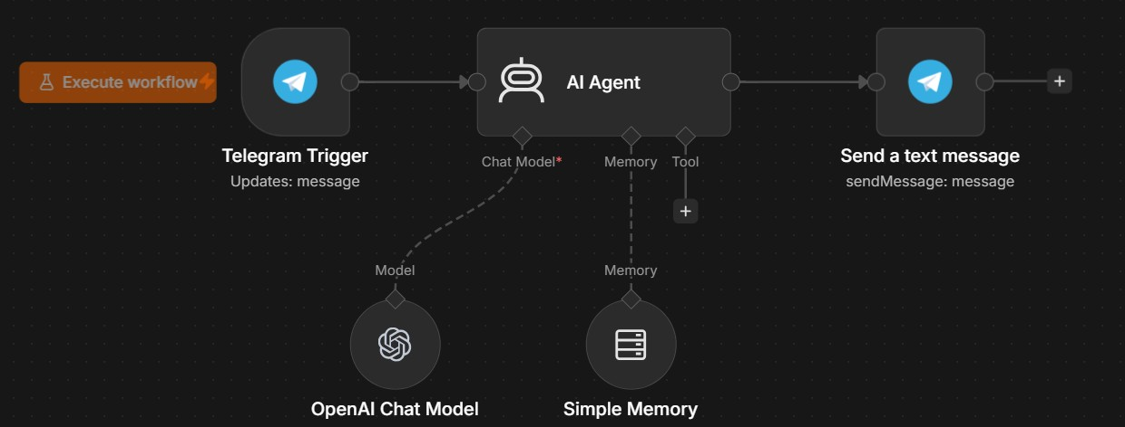
Figure 4: The finished Activity 4 workflow.

Credentials needed for this activity
- Telegram Bot token — from BotFather (see Before You Begin).
- OpenAI API key — from platform.openai.com (see Before You Begin).

Step-by-step build

Step 1 — Create the Telegram bot and credential
- In Telegram, message @BotFather, send /newbot, and follow the prompts to get your bot’s API token.
- In n8n, create a Telegram credential, paste the token, and save it as Telegram account.

Step 2 — Add the Telegram Trigger
- Add a Telegram Trigger node and select your Telegram account credential.
- Under Trigger On / Updates, select message so the workflow fires whenever your bot receives a chat message.
- Click Listen for event (test mode), then send your bot a message in Telegram to capture a sample. This makes fields like message.text and message.chat.id available to later nodes.

Step 3 — Add the AI Agent
- From the Telegram Trigger, add an AI Agent node.
- Set Source for Prompt (User Message) to Define below.
- In the prompt/text field, enter the expression: {{ $json.message.text }} — this feeds the user’s Telegram message to the agent.
- (Optional) Add a System Message to set the bot’s personality, e.g. “You are a friendly assistant. Keep replies short.”

Step 4 — Attach the OpenAI Chat Model
- On the AI Agent, click the Chat Model* connector underneath (the port marked with a red asterisk) and add OpenAI Chat Model.
- Select your OpenAI account credential.
- Set Model to gpt-4o.
- This is the language model the agent uses to think and write replies.

Step 5 — Attach Simple Memory
- On the AI Agent, click the Memory connector and add Simple Memory (Window Buffer Memory).
- Leave the defaults — it keeps the most recent messages so the agent has conversational context.
- Memory is keyed per session; for a single chat the default settings are fine.

Step 6 — Send the reply back to Telegram
- From the AI Agent’s main output, add a Telegram → Send a text message node and select your Telegram account credential.
- Set the Chat ID and Text fields as shown below so the bot replies to the right person with the AI’s answer.
Field | Value to enter | Why
Chat ID | {{ $('Telegram Trigger').item.json.message.chat.id }} | Replies to whoever sent the message
Text | {{ $json.output }} | Sends the AI Agent’s generated reply

Note on the sample file: the provided Activity 4 workflow contains placeholder test values — Chat ID 1194494611 and Text “test”. Replace them with the dynamic expressions above so the bot replies to the actual sender with the AI’s answer instead of a fixed test message.

Step 7 — Activate and test
- Confirm the wiring: Telegram Trigger → AI Agent → Send a text message, with OpenAI Chat Model and Simple Memory connected under the AI Agent.
- Save and toggle the workflow Active.
- Open Telegram, message your bot (e.g. “Hello, what can you do?”), and wait for the AI reply.
- Send a follow-up that refers to your previous message to confirm memory is working.
Checkpoint: Messaging your Telegram bot returns an AI-generated reply, and the agent remembers earlier turns in the conversation.

How the AI Agent fits together
- Telegram Trigger — listens for incoming messages and starts the workflow.
- AI Agent — the brain; it receives the user’s message, consults its model and memory, and produces a reply.
- OpenAI Chat Model — the language model (GPT-4o) the agent uses to generate text.
- Simple Memory — stores recent messages so replies stay in context.
- Send a text message — delivers the agent’s reply back into the Telegram chat.

Activity 5: Retrieval-Augmented Generation (RAG)

Goal
Build an AI assistant that answers questions from your own document instead of from the model’s general knowledge. In this activity you upload a microwave product manual (a PDF), n8n converts it into a searchable knowledge base, and a chat agent answers questions such as “What is the model?” by retrieving the relevant pages from that manual.

What is RAG?
Retrieval-Augmented Generation means the AI first retrieves relevant text from a knowledge base, then generates its answer using that text. This keeps answers grounded in your document and reduces made-up (“hallucinated”) responses. The knowledge base is a vector store: your document is split into chunks, each chunk is turned into a numeric embedding, and at question time the chunks most similar to the question are fed to the model.

Workflow overview
This workflow has two independent parts that share one in-memory vector store:
- Part A — Ingestion (build the knowledge base): On form submission (file upload) → Extract from File (PDF) → Simple RAG Vector Store (insert mode). A Default Data Loader + Recursive Character Text Splitter prepare the text, and Embeddings OpenAI turns it into vectors.
- Part B — Query (chat with the knowledge base): When chat message received → AI Agent1 → reply. The agent is backed by an OpenAI Chat Model, Simple Memory, and the Simple RAG vector store connected as a tool.
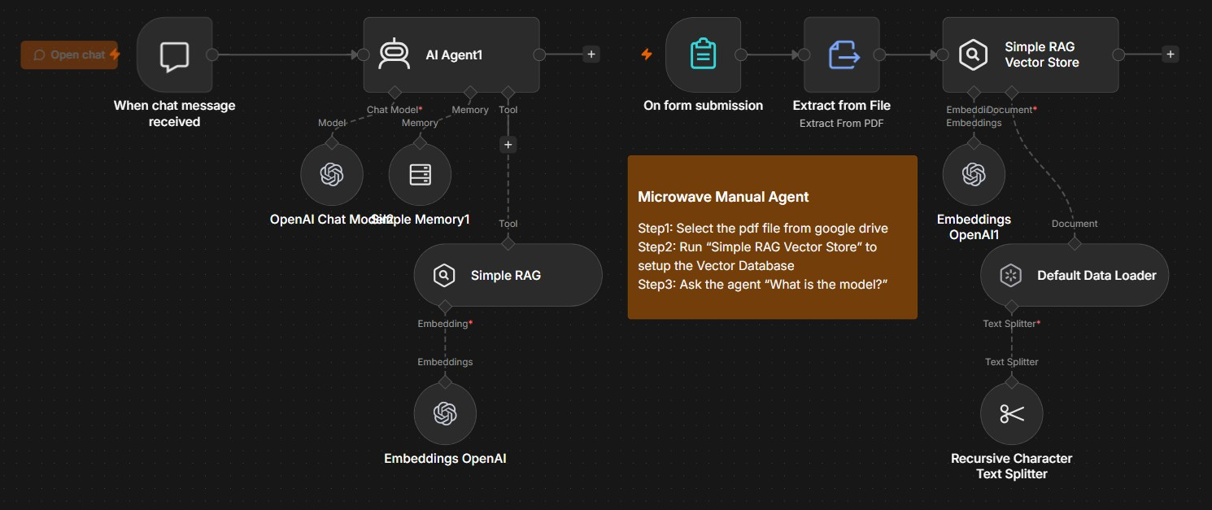
Figure 5: The finished Activity 5 workflow — query chain (left) and ingestion chain (right).

Credentials needed
- OpenAI API key — used twice in this workflow: once for the embeddings (to vectorize the document) and once for the chat model (to answer). See Before You Begin.

Build — Part A: Ingestion (build the knowledge base)

Step 1 — Upload form
- Add an On form submission node. Set Form Title to File to Upload and Form Description to Upload Knowledge File.
- Add one form field: Field Type = File, Field Label = Knowledge File. This lets you upload the PDF manual.

Step 2 — Extract from File
- Add an Extract from File node after the form.
- Operation: Extract from PDF.
- Input Binary Field: Knowledge_File (this is the uploaded file’s binary property).

Step 3 — Simple RAG Vector Store (insert)
- Add a Simple Vector Store (In-Memory) node and connect Extract from File into it.
- Operation Mode: Insert Documents.
- Memory Key: vector_store_key.
- Enable Clear Store so re-uploading replaces the old data instead of duplicating it.

Step 4 — Document loader + splitter (under the vector store)
- On the vector store’s Document input, add a Default Data Loader. Set Type of Data = JSON, Mode = Load Specific Data, and JSON Data to the expression {{ $json.text }} (the text Extract from File produced). Set Text Splitting = Custom.
- On the Data Loader’s Text Splitter input, add a Recursive Character Text Splitter. Set Chunk Size = 2000 and Chunk Overlap = 200.
- On the vector store’s Embedding input, add an Embeddings OpenAI node and select your OpenAI credential.
What this does: the PDF text is split into ~2000-character chunks (with 200-character overlap so sentences are not cut awkwardly), each chunk is embedded, and all chunks are stored under the key vector_store_key.

Build — Part B: Query (chat with the knowledge base)

Step 5 — Chat trigger
- Add a When chat message received node. Set it to Public so it gets a hosted chat URL (mode: webhook).
- This is a separate starting point from the upload form — it is the chat window users type into.

Step 6 — AI Agent
- Add an AI Agent node after the chat trigger.
- Open Options → System Message and enter: You are a microwave assistant. You only query from the database and answer the user question {{ $json.chatInput }}

Step 7 — Attach the model, memory, and the RAG tool
- Chat Model: add an OpenAI Chat Model, choose model gpt-4o-mini, and select your OpenAI credential.
- Memory: add a Simple Memory node. Set Session Key to Custom Key with the expression {{ $('When chat message received').item.json.sessionId }} so each chat keeps its own history.
- Tool: on the AI Agent’s Tool input, add a second Simple Vector Store (In-Memory) node named Simple RAG. Set Operation Mode = Retrieve Documents (As Tool for AI Agent), Memory Key = vector_store_key (the SAME key as Part A), Limit = 5, and Tool Description = this is the microwave manual vector databases.
- On that Simple RAG node’s Embedding input, add another Embeddings OpenAI node with your OpenAI credential.
Important: both vector-store nodes must use the same Memory Key (vector_store_key) and the same embeddings model. The query side can only read what the ingestion side wrote.

Step 8 — Run it (the three-step routine)
- Open the chat-upload form and upload your PDF (for example, a microwave manual).
- Manually run the Simple RAG Vector Store (insert) node so the document is chunked, embedded, and stored.
- Open the chat (the When chat message received URL) and ask, for example, “What is the model?” The agent retrieves the matching pages and answers from the manual.
Checkpoint: The agent answers using facts from your uploaded PDF. If it says it has no information, re-run the vector-store insert and confirm both nodes share the key vector_store_key.

Activity 6: Webhook Chatbot

Goal
Expose an AI agent as a web service. Instead of a built-in chat window, this workflow listens on a public webhook URL. Any app, website, or tool that sends an HTTP request to that URL gets an AI-generated reply back. This is how you embed an n8n AI agent into your own front-end.

Workflow overview
Webhook → AI Agent → Respond to Webhook. The Webhook node receives the incoming request, the AI Agent (powered by an OpenAI Chat Model) generates a response, and Respond to Webhook returns that response to the caller.
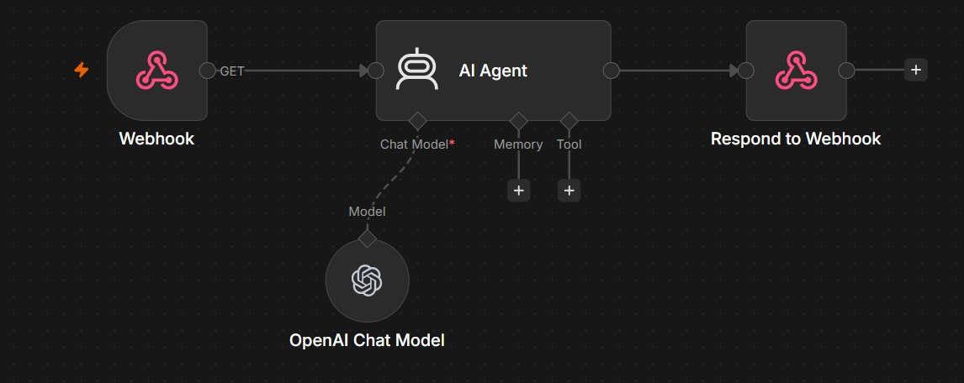
Figure 6: The finished Activity 6 workflow.

Credentials needed
OpenAI API key (for the chat model). No other credentials are required — the webhook is public.

Step-by-step build

Step 1 — Webhook trigger
- Add a Webhook node (it becomes the trigger). Set HTTP Method to GET.
- n8n auto-generates a Path (a random ID such as 18738f74-d027-405c-9b54-bab901e3ef5d). You can keep it or set your own.
- Under Options, add Allowed Origins (CORS) and set it to * so browsers can call it.
- The node shows two URLs: a Test URL (works only while you click “Listen for test event”) and a Production URL (works once the workflow is active).

Step 2 — AI Agent
- Add an AI Agent node after the Webhook.
- Set the prompt source so the agent reads the caller’s question. For a GET request, the text arrives as a query parameter — set the User Message to an expression such as {{ $json.query.text }} (match the parameter name you send).
- Leave the other options at their defaults for this simple bot.

Step 3 — Attach the OpenAI Chat Model
- On the AI Agent, click the Chat Model* connector and add an OpenAI Chat Model.
- Select your OpenAI credential and choose the model (this workflow uses gpt-5-mini; gpt-4o-mini is a fine alternative).

Step 4 — Respond to Webhook
- Add a Respond to Webhook node after the AI Agent.
- By default it returns the previous node’s output — i.e. the agent’s reply — to whoever called the webhook.
- Without this node the caller would get an empty acknowledgement instead of the answer.

Step 5 — Activate and test
- Save and activate the workflow so the Production URL goes live.
- Test by opening the Production URL in a browser with a query string, e.g. https://…/webhook/<path>?text=Hello, or send a request from Postman or curl.
- You should receive the AI agent’s reply in the HTTP response.
Checkpoint: Calling the webhook URL returns an AI-generated answer in the response body.

Webhook vs. chat trigger
The Chat Trigger used in Activity 5 gives you n8n’s ready-made chat window. A Webhook gives you a raw HTTP endpoint with no UI — more work to call, but it lets you plug the agent into any external system you build.

Activity 7: HTTP Request

Goal
Call an external REST API from n8n and pull live data into your workflow. Here you fetch stock-market data for Apple (AAPL) from the Twelve Data API — both a price time series and a technical indicator — reusing one set of parameters (API key, symbol, interval) across two parallel HTTP requests.

Workflow overview
When clicking ‘Execute workflow’ (manual trigger) → Config (a Set node holding the API key, symbol, and interval) → two HTTP Request nodes that run in parallel: Time Series and Technical Indicators. Both read their values from the Config node.
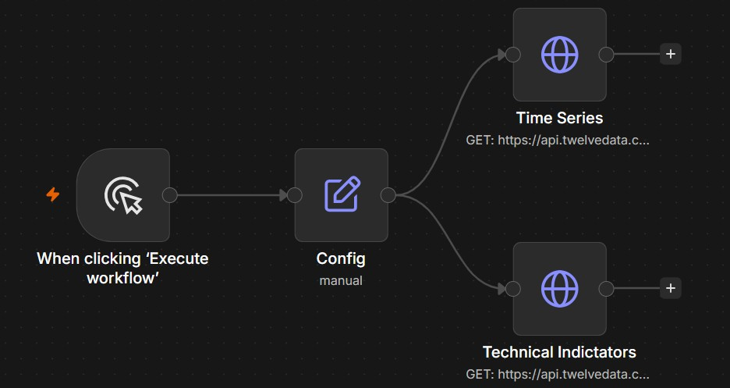
Figure 7: The finished Activity 7 workflow.

Get a Twelve Data API key
- Go to twelvedata.com and create a free account.
- Open your dashboard → API Keys and copy your key (a long string like 51bc813a4d5c4131b7252891fe1a6860).
- The free tier is enough for this activity. The key is passed as a query parameter named apikey on every request.

Step-by-step build

Step 1 — Manual trigger
Add a When clicking ‘Execute workflow’ (manual trigger) node so you can run the workflow on demand while testing.

Step 2 — Config (Set node)
Add a Set (Edit Fields) node named Config after the trigger. Add three string fields so every request reuses the same values:
Field name | Value
API Key | 51bc813a4d5c4131b7252891fe1a6860 (your own key)
Symbol | AAPL
Interval | 1min

Step 3 — Time Series HTTP request
- Add an HTTP Request node named Time Series after Config.
- Method: GET. URL: https://api.twelvedata.com/time_series
- Turn on Send Query Parameters and add the three parameters below (values are expressions that read from Config):
Query parameter | Value (expression)
symbol | {{ $json.Symbol }}
interval | {{ $json.Interval }}
apikey | {{ $json['API Key'] }}

Step 4 — Technical Indicators HTTP request
- Add a second HTTP Request node named Technical Indicators, also connected to Config (so the two run in parallel).
- Method: GET. URL: https://api.twelvedata.com/ad (the /ad endpoint returns the Accumulation/Distribution indicator).
- Send the same three query parameters (apikey, symbol, interval) using the same expressions as Step 3.

Step 5 — Run and inspect
- Click Execute workflow.
- Open each HTTP Request node’s output: Time Series returns price candles; Technical Indicators returns indicator values for AAPL.
- Change Symbol or Interval in the Config node and re-run — both requests update automatically.
Checkpoint: Both HTTP nodes return live JSON data from Twelve Data for the symbol set in Config.

Why a Config node?
Storing the API key, symbol, and interval once in a Set node keeps your workflow tidy: you change a value in a single place and every downstream request picks it up. It also keeps the key out of each individual node, which is easier to maintain.

Activity 8: AI Guardrail

Goal
Add a safety check that scans text for sensitive data — API keys, passwords, secrets — before it is allowed through. Any item that contains a secret is blocked and routed to a human for approval by email; clean items pass straight through. This is a basic data-loss-prevention (DLP) guardrail.

Workflow overview
When clicking ‘Execute workflow’ → Edit Fields (a list of test messages) → Split Out (one message per item) → Secret Keys (the Guardrails node). The Guardrails node has two outputs: Pass (no secret found) ends quietly, and Fail (a secret was detected) goes to Send message and wait for response, which emails an approver.
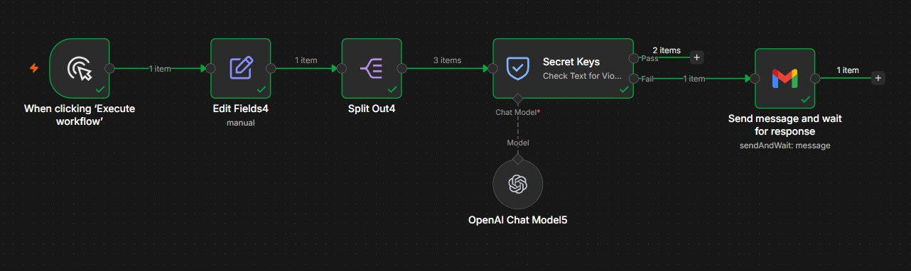
Figure 8: The finished Activity 8 workflow (2 items pass, 1 item fails).

Credentials needed
OpenAI API key (the Guardrails node uses a model to detect secrets) and your Gmail credential (for the approval email).

Step-by-step build

Step 1 — Manual trigger
Add a When clicking ‘Execute workflow’ (manual trigger) node so you can run the test on demand.

Step 2 — Edit Fields (sample data)
- Add an Edit Fields (Set) node.
- Add one field named 1 of type Array and paste the three test messages as its value:
['The API key is sk-abc123XYZ456.',
'Use my password: P@ssw0rd! for the database.',
'Connect your account to n8n for automation.']
The first two strings contain a secret (an API key and a password); the third is harmless.

Step 3 — Split Out
- Add a Split Out node so each message is processed individually.
- Set Field to Split Out to '1' (the array field from the previous node).
- After this node you have three separate items instead of one array.

Step 4 — Secret Keys (Guardrails node)
- Add a Guardrails node and rename it Secret Keys.
- Set Text to the field coming from Split Out (the expression {{ $json['[\'1\']'] }} in this build — point it at whatever field name your Split Out produced).
- Choose the Secret Keys guardrail and set Permissiveness to Strict so it flags anything that looks like a credential.
- Attach an OpenAI Chat Model to the node’s Chat Model* connector (this build uses gpt-4.1-mini) and select your OpenAI credential.
The node produces two outputs: output 1 = Pass (text is clean) and output 2 = Fail (a secret was found).

Step 5 — Email approval on the Fail branch
- From the Fail output, add a Gmail node and set its Operation to Send and Wait for Response.
- To: agenticautomation88@gmail.com. Subject: Secret Key Guardrail. Message: secret key detected.
- Set the approval type to Approval (double) so the recipient gets Approve / Disapprove buttons and the workflow pauses until they respond.
- Leave the Pass output unconnected — clean items simply continue with no action.

Step 6 — Run and observe
- Click Execute workflow. Watch the Secret Keys node: 2 items take the Pass output and 1 item takes the Fail output.
- Check the inbox for agenticautomation88@gmail.com — an approval email arrives for the message that contained a secret.
- The workflow stays paused on that branch until the approver clicks a button.
Checkpoint: Messages with secrets are caught and escalated for approval, while clean messages pass through untouched.

Why guardrails matter
When AI agents handle real user input, they can accidentally expose or act on sensitive data. A guardrail is a checkpoint that inspects content and enforces a policy — here, holding anything with a credential for human review before it goes any further.

You’re Done!
Congratulations — you have built eight n8n workflows covering forms, email, branching logic, data tables, AI agents, retrieval-augmented generation, webhooks, external APIs, and safety guardrails. Here is the full set:
- Activity 1 — Flyer with QR Code: a form trigger that emails each enquiry, published as a QR-code flyer.
- Activity 2 — Capture Data in a Table: an RSVP form that branches on attendance and writes every response to a Data Table.
- Activity 3 — Conditional Response: the If node with a No Operation branch to act only when needed.
- Activity 4 — Telegram-Triggered AI Agent: a Telegram bot powered by GPT-4o with conversation memory.
- Activity 5 — Retrieval-Augmented Generation: a chat agent that answers from your own uploaded PDF via a vector store.
- Activity 6 — Webhook Chatbot: an AI agent exposed as a callable HTTP endpoint.
- Activity 7 — HTTP Request: pulling live data from an external REST API (Twelve Data) with shared parameters.
- Activity 8 — AI Guardrail: a secret-detection check that escalates risky content for human approval.

Where to go next
Combine what you have learned: add a guardrail in front of your RAG agent, log webhook conversations into a Data Table, or trigger the HTTP request on a schedule. Each node you have met here is reusable across hundreds of automation ideas.

